**TASK 3**

**What does risk assessment mean?**

**It is to identify the procedure of hazards which are affecting negatively on the ability of a work place in accordance to business. With the help of risk assessment, we can identify the risk which can occur in business and give us the alternative to remove these risks or to decrease the factor of risk. With the help frame RAF helps assessment framework, which can cause some risks to the company’s work structure the hazards in a company identified by the help of RAF can also give us the effective solutions to the remove either reduce the risk factor.**

**The importance of risk factor:**

**It is very important and it plays a vital role in safety for industries and health management.**

**it can help us in the followings:**

* **Note down of the hazards and risk when the employee were aware of their health and the safety risk which they meet in the workplace we have to promote the health and safety concerns for workers by practices knowledge about safety and health hazards among employee about risk awareness and safe work practices to understand where prevention efforts should be based**
* **Harms to be identified (employees, workers, student, cleaners, visitors etc.)**
* **What is important for a specific hazard**

**TASK 4B**

**What is meant by control measures?**

These are measures and methods for avoiding, minimizing or reducing the occurrence of a threat found

.by you

Control measures to avoid accidents are:

1. Provide a proper set of the training to the workers in the workspace.

To get a better idea of the tasks they are assigned, each and every employee should be given adequate training and instruction. This helps a worker to have a proper understanding of the danger that could arise if certain measures know how to deal with these risk factors

1. Stay updated on the maintenance of machinery in the workplace.

Maintaining the equipment in a good and safe working condition is important for employees who are entrusted by their employers to work daily at such sites. It can increase the worker's risk of injury if the equipment supplied fails, which can also have a direct impact on the quality of the job.

1. Keeping workspace clean

To minimize the likelihood of accidents in the workplace, keeping a clean environment is very important because it serves a key role in lowering the risk of injuries to anybody in the working environment. Due to a cabling on the concrete, e.g. tripping due to the wiring on the floor.

1. post correct signage

In the areas visible and in places in which the same procedures have to be conducted, employers should provide signage that would inform staff of the required safety measures.

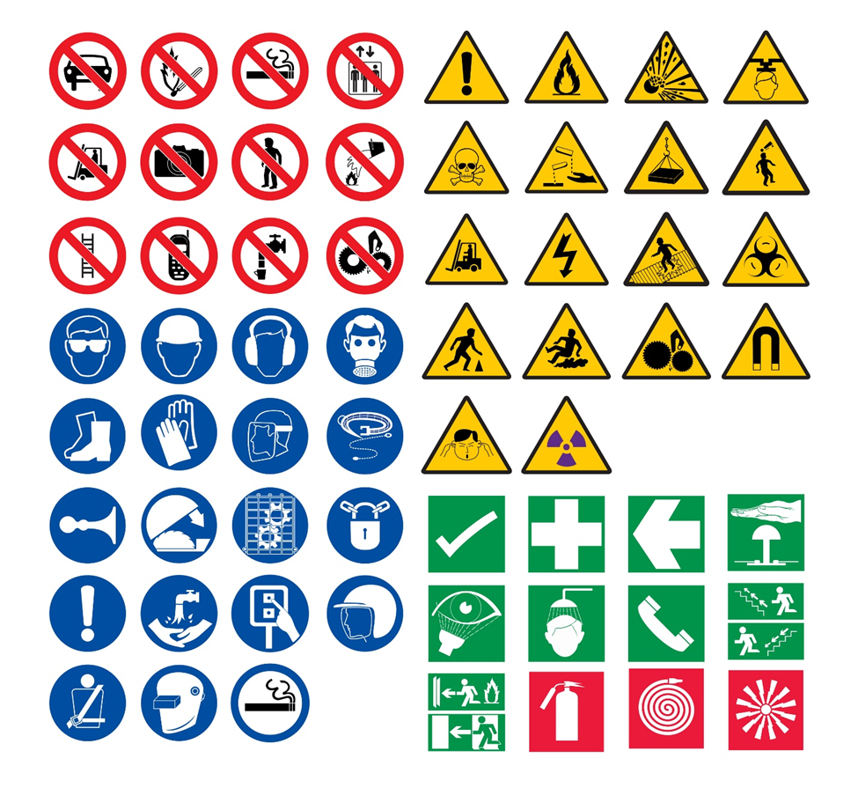

Figure 3 Safety signage and your

